Sending an s/mime email using a self-signed x509 certificate:

These step by step instructions will demonstrate how to send an s/mime encrypted email in Outlook between two users ([ethan.a.blanton@gmail.com](mailto:ethan.a.blanton@gmail.com) and [eblant1@students.towson.edu](mailto:eblant1@students.towson.edu))

Within outlook go to File->Options->Trust Center and click on the import certificate button shown below

Click “Import/Export” and find your certificate:

Then, create a new encryption profile for that certificate by clicking “Settings” under encrypted email and choosing the certificate for that account for both the Signing and Encryption Certificate:

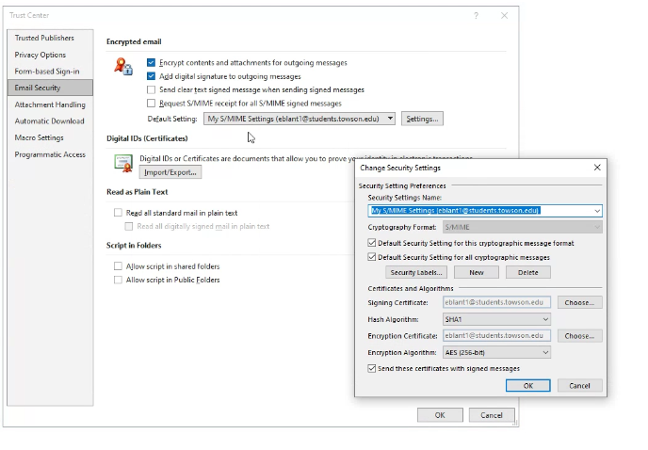

Do the same with the recipient email:

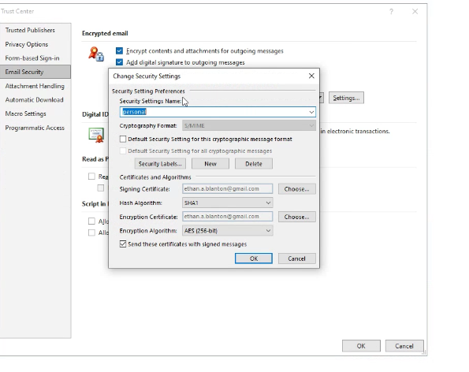

Then, send a signed email from the recipient to the sender so that the public key is shared.

Signed email from the recipient:

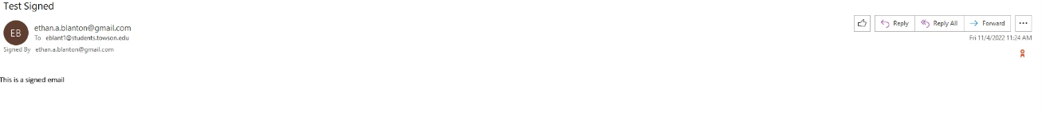

Note: the orange icon on the left indicates that the email is a valid signed email.

Now, add the recipient as a contact within outlook by right clicking on their name and selecting “Add to Outlook Contacts.” This saves the contact within outlook and allows for encrypted emails to be exchanged.

After saving the recipient as a contact, the sender can send an encrypted message:

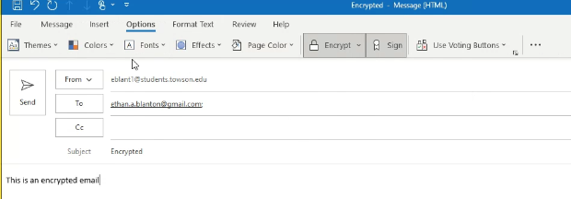

The recipient can receive and decrypt the email

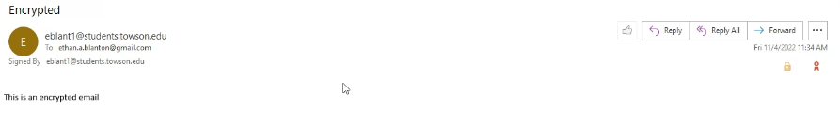

Note: The gold lock icon indicates that the email is encrypted.